**Payroll Management System**

**Professor: Enayat Rajabi**

**Course Code: MGSC 5106**

**Course Name: Database Concepts**

**Submitted by: Ajay Pratap Singh Rathore**

**Jinal Ajay Patel**

**Kristine Mae Pogoy**

**Background**

**Problem Statement:** Zen Tech IT services has old Payroll Management System where Employees make manual attendance and get hard-copies of Pay-slips and Tax-slips from Accounts Department. Employees didn’t received benefits in taxes through different modes of Allowances instantly.

**Solution:** In order to maintain the prestige and reputation in Technology market, the company has planned to upgrade its Payroll Management System, this will enable efficiently accurate recording and hassle-free for their payroll department. The new Payroll Management System will include - Paid Leaves, Taxes, Medical and expenses allowances, working and non-working dates, bonuses irrespective of different Departments in just one click. All the Employees will get default credentials to access new Payroll system to get hassle-free Salary slips anytime and everywhere.

**Description**

Red : Entity

Blue : Attribute

Green : Relationship

* Employees are having Employee ID, Employee Name, Designation, Phone number, Address, Postal Code and Bank Account number which works for Department, which are having Department ID and Department Name. Each Employee who is works for a Department includes Date of Joining, Date of termination and Type of Employment (Fulltime/Part-time).
* Employees can take multiple leaves with timestamp to and from. Specific leaves (sick leave) can be taken by many employees. Leaves contains Leave ID and Type of leave. Employees monthly working days are calculated based on the number of leaves and its reason.
* Every month of the year an employee receives Salary which includes – Transaction ID, Net Income and Gross Income. Employee will get a salary once a month.
* Deductions, Allowances and Compensation will be based on each employees designation. Zen Tech’s Account department will calculates it.
* Deduction in Salary have Deduction ID, Income Tax, Professional Tax, Loan and Pension funds.
* Allowances have Allowance ID, Medical Allowance, House Rent Allowance and Travel Allowance. Employees will get credentials on their email address to get benefit of Allowances to reduce Taxes.
* Compensation have Compensation ID, Bonus and yearly Appraisal.

**Entity Relationship Diagram**

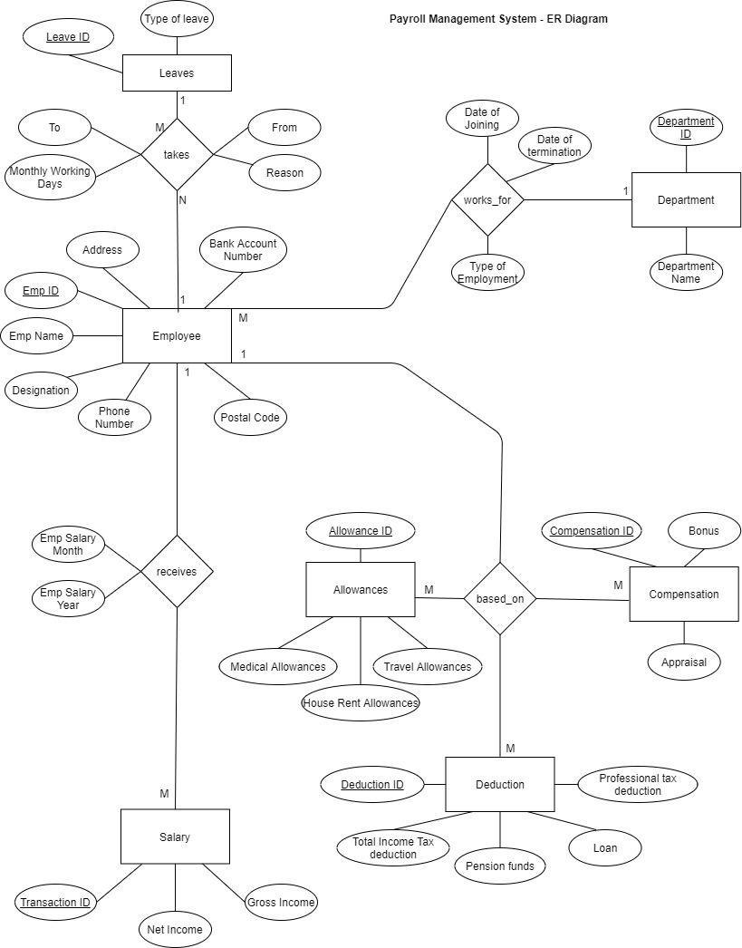

**Relational Model**

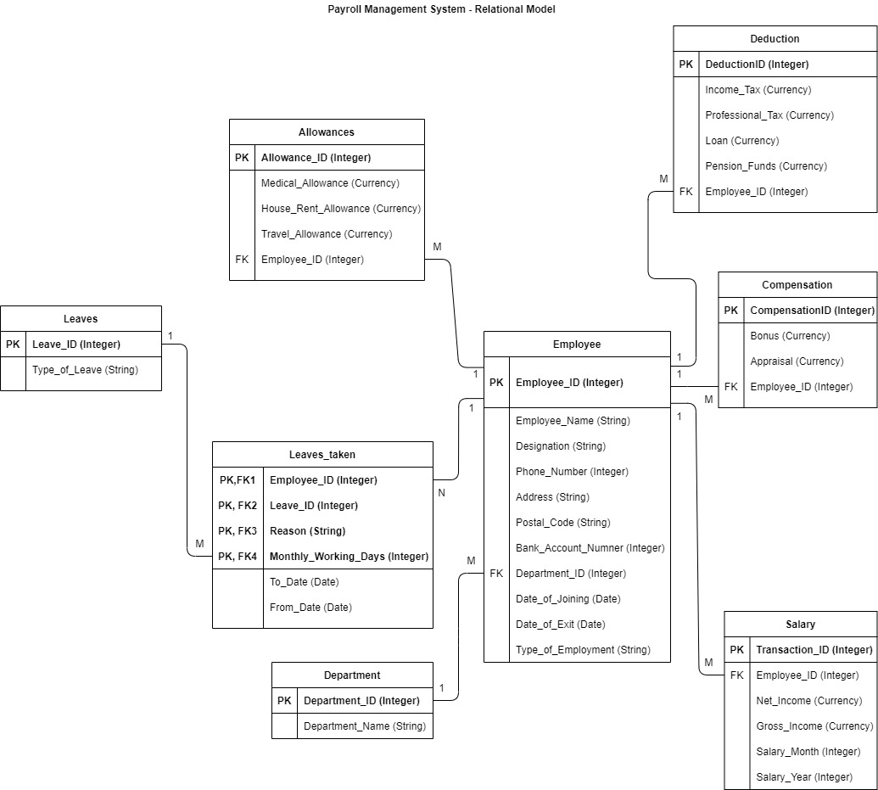

**MySQL Tables**

**Salary Table:**

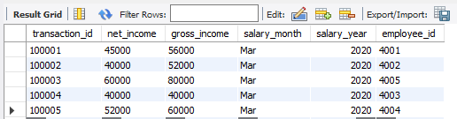

**Employee Table:**

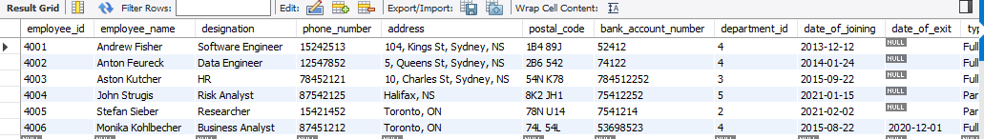

**Department Table:**

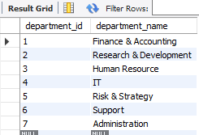

**Leaves Table:**

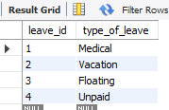

**Leaves Taken Table:**

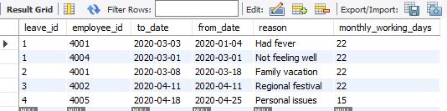

**Allowances Table:**

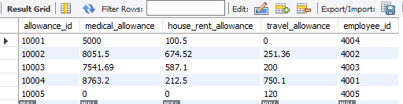

**Compensation Table:**

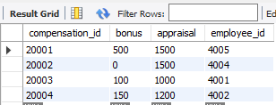

**Deduction Table:**

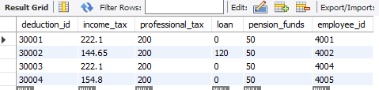

**SQL Queries and Results**

**1. Name of the software engineers whose bonus is more than Rs 100?**

**Query:**

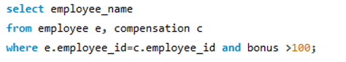

**Result:**

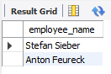

**2. How many employees taken medical leaves in 2020?**

**Query:**

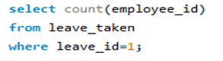

**Result:**

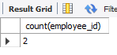

**3. Details of the employees works in HR department?**

**Query:**

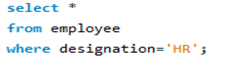

**Result:**



**4. Name the employees who pays income tax and do not apply for travel allowances?**

**Query:**

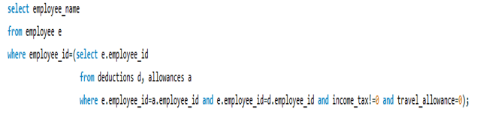

**Result:**

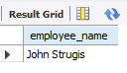

**5. How much salary is received by a research department employees?**

**Query:**

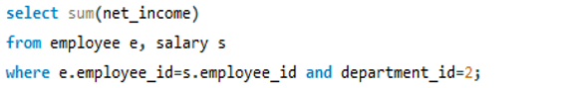

**Result:**

